**lab 2**

**Prac_1:- Write a program to check if a given year is a leap year. (A year is a leap year if it is divisible by 4 but not by 100, or it is divisible by 400.**

**Program: package** leapyear;

**import** java.util.Scanner;

**public** **class** leapyear {

**public** **static** **void** main(String[] args) {

// Create a Scanner object to read input from the user

Scanner sc = **new** Scanner(System.***in***);

**boolean** running = **true**;

// Loop to continuously ask for a year until the user enters 0

**while** (running) {

System.***out***.println("Enter the year (enter 0 to exit):");

**int** res = sc.nextInt(); // Read the input year

// Check if the user wants to exit

**if** (res == 0) {

running = **false**; // Set running to false to exit the loop

System.***out***.println("Exiting...");

**break**; // Exit the loop

}

// Check if the year is a leap year

**if** (res % 4 == 0) {

**if** (res % 100 == 0) {

**if** (res % 400 == 0) {

System.***out***.println(res + " is a leap year");

} **else** {

System.***out***.println(res + " is not a leap year");

}

} **else** {

System.***out***.println(res + " is a leap year");

}

} **else** {

System.***out***.println(res + " is not a leap year");

}

}

// Close the Scanner object to free up resources

sc.close();

}

}

**Output:** 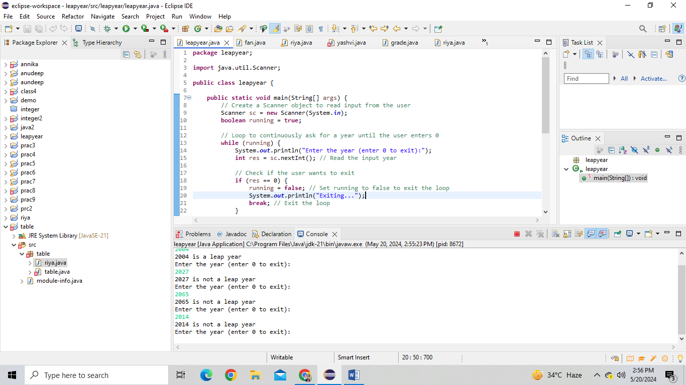

**Prac_2:- Write a program that takes an integer as input and checks if it is positive, negative, or zero.**

**Program: package** integer2;

**import** java.util.Scanner;

**public** **class** integer {

**public** **static** **void** main(String[] args) {

// Create a Scanner object to read input from the console

Scanner sc = **new** Scanner(System.***in***);

// Boolean flag to control the loop

**boolean** prog = **true**;

// Loop until the user decides to exit

**while** (prog) {

System.***out***.println("Enter the number or type 'exit' to quit:");

String ch = sc.nextLine();

// Check if the user wants to exit

**if** (ch.equals("exit")) {

prog = **false**;

**break**;

}

**try** {

// Parse the input to an integer

**int** num = Integer.*parseInt*(ch);

// Check if the number is positive, negative, or zero and print the corresponding message

**if** (num > 0) {

System.***out***.println(num + " is a positive integer number.");

} **else** **if** (num < 0) {

System.***out***.println(num + " is a negative integer number.");

} **else** {

System.***out***.println(num + " is zero.");

}

} **catch** (NumberFormatException e) {

// Handle the case where the input is not a valid integer

System.***out***.println("Invalid input. Please enter a valid integer.");

}

}

// Close the scanner

sc.close();

}

**public** **static** **int** parseInt(String ch) {

// **TODO** Auto-generated method stub

**return** 0;

}

}

**Output:** 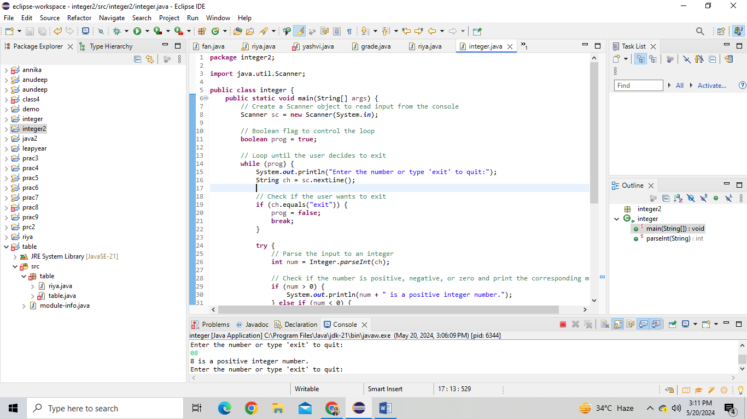

**Prac_3:- Write a program that takes an integer as input and prints its multiplication table up to 10.**

**Program: package** table;

**import** java.util.Scanner;

**public** **class** riya {

**public** **static** **void** main(String[] args) {

// Create a new Scanner object for reading input

Scanner sc = **new** Scanner(System.***in***);

// Infinite loop to repeatedly ask for a number and print its multiplication table

**while** (**true**) {

// Prompt the user to enter a number

System.***out***.println("Enter a number (or type 'exit' to quit):");

// Check if the input is an integer or the exit command

**if** (sc.hasNextInt()) {

// Read the number from the user

**int** num = sc.nextInt();

// Initialize the counter for the multiplication table

**int** a = 1;

// Loop to print the multiplication table from 1 to 10

**while** (a <= 10) {

// Calculate the product of the number and the counter

**int** ans = num * a;

// Print the result

System.***out***.println(num + " * " + a + " = " + ans);

// Increment the counter

a++;

}

} **else** {

// Read the next input as a string

String input = sc.next();

// Exit the loop if the user types 'exit'

**if** (input.equalsIgnoreCase("exit")) {

**break**;

} **else** {

// Inform the user about invalid input

System.***out***.println("Invalid input. Please enter a number or type 'exit' to quit.");

}

}

}

// Close the scanner object

sc.close();

}

}

**Output:** 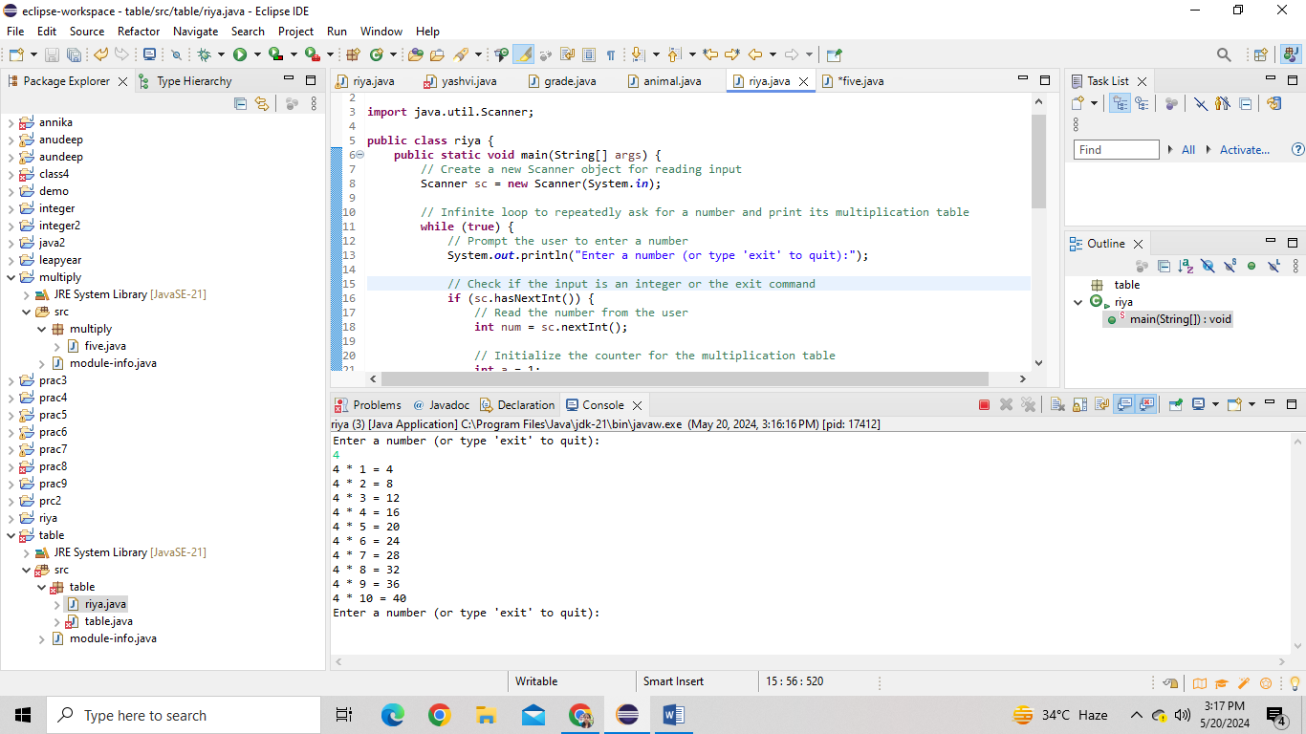

**Prac_4:- Write a program that takes a positive integer as input and prints its digits in reverse order.**

**Program: package** aundeep;

**import** java.util.Scanner;

**public** **class** riya {

**public** **static** **void** main(String[] args) {

{ **while**(**true**) {

Scanner sc = **new** Scanner(System.***in***); System.***out***.print("Enter the number: "); **int** num = sc.nextInt(); **int** ans = 0; **while**(num>0) {

**int** rem = num % 10; num /= 10; ans = ans * 10 + rem;

}

System.***out***.println(ans);

}

}

}

}

**Output:** 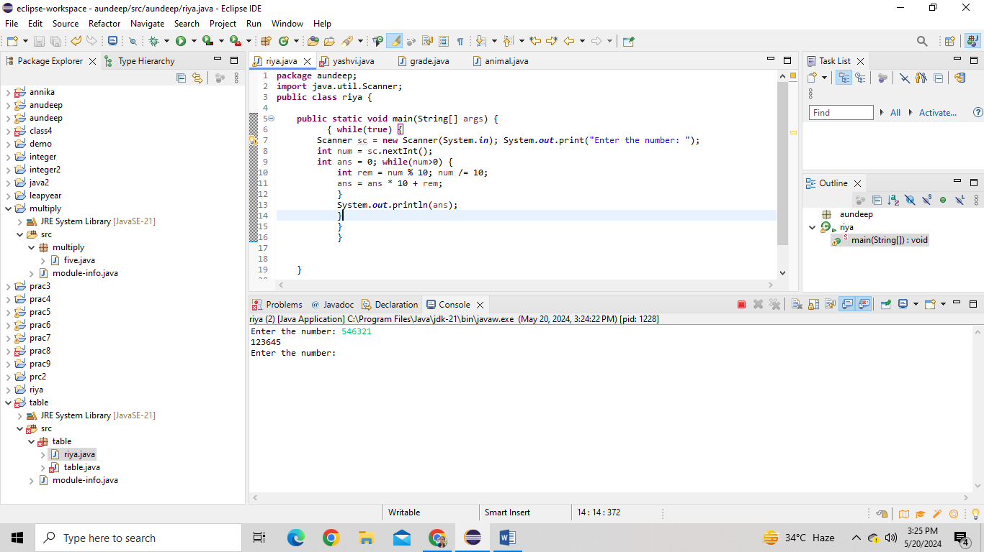

**Prac_5:- Write a program that prints numbers from 1 to 10 using a loop.**

**Program: package** annika;

**public** **class** yashvi {

**public** **static** **void** main(String[] args) {

**int** a = 1;

**while**(a<=10) {

System.***out***.println(a);

a++;

}

}

}

**Output:** 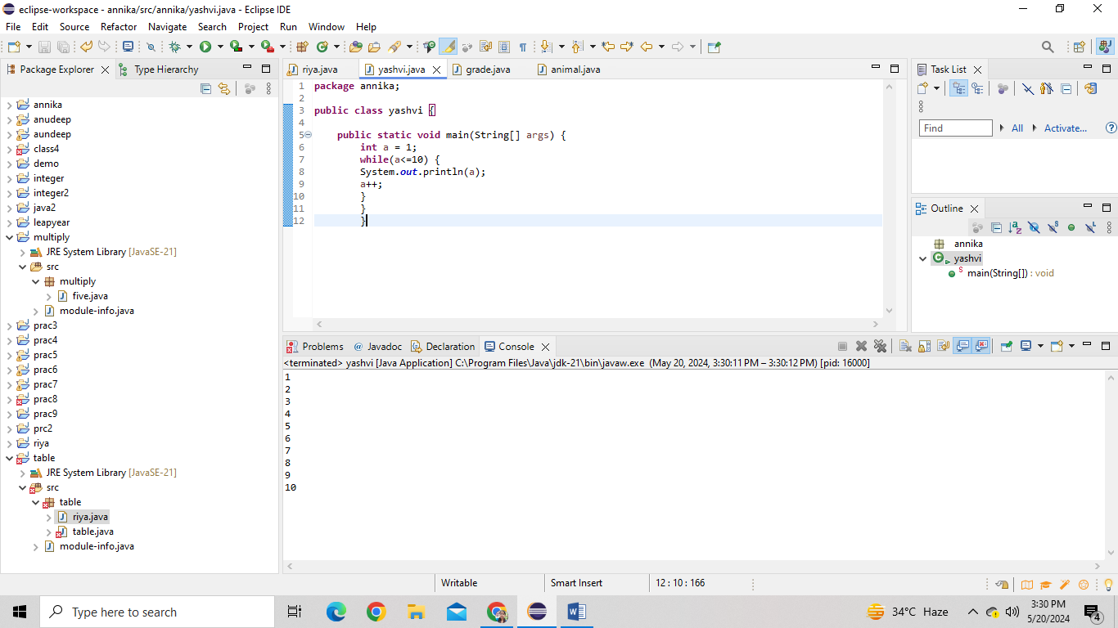

**Prac_6:- Write a program that takes an integer N as input and calculates the sum of entered numbers.**

**Program: package** annika;

**import** java.util.Scanner;

**public** **class** yashvi {

**public** **static** **void** main(String[] args) {

Scanner scanner = **new** Scanner(System.***in***);

System.***out***.print("Enter the number to sum: ");

**int** N = scanner.nextInt();

**int** sum = 0;

**for** (**int** i = 0; i < N; i++) {

System.***out***.print("Enter number " + (i + 1) + ": ");

**int** num = scanner.nextInt();

sum = sum + num;

}

System.***out***.println("Sum of entered numbers: " + sum);

scanner.close();

}

}

**Output:** 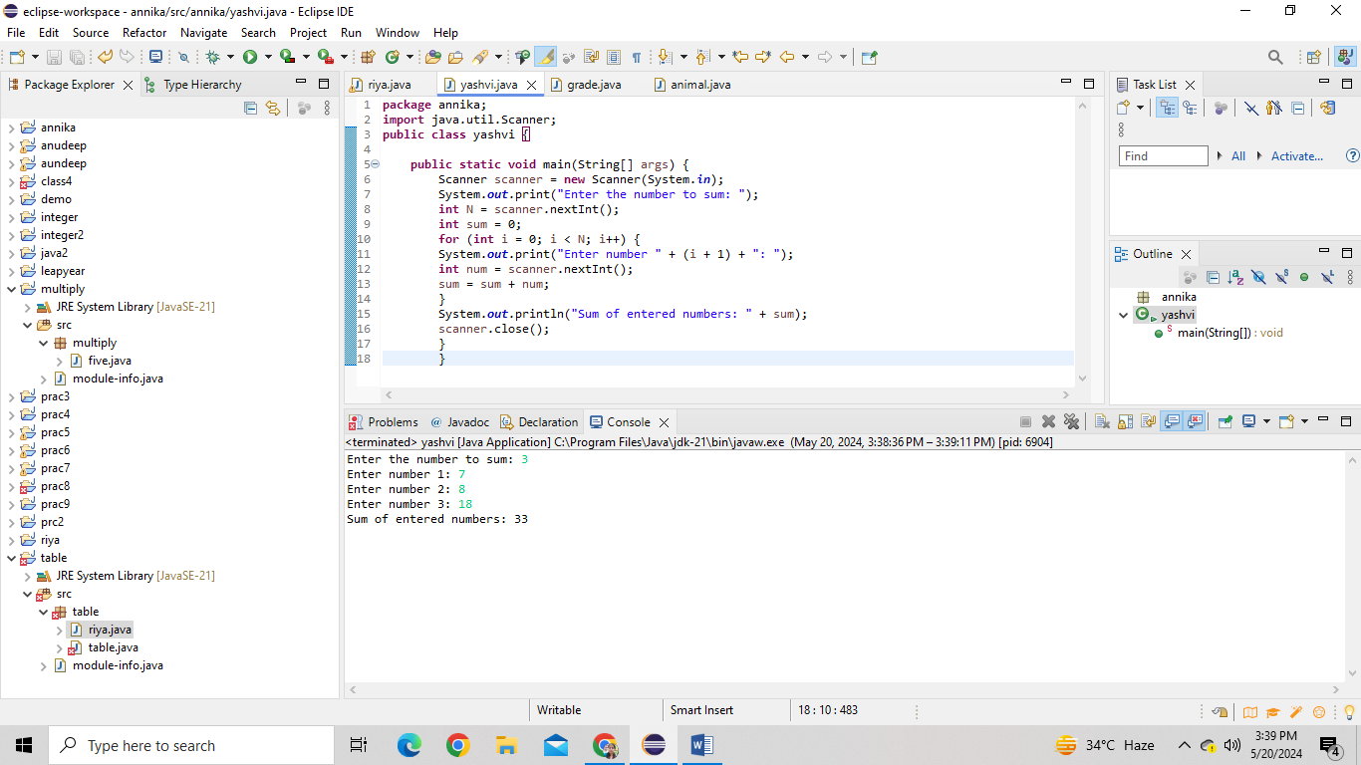

**Prac_7:- Write a program that takes a student's score as input and outputs the corresponding grade based on the following scale:**

**Program: package** java2;

**import** java.util.Scanner;

**public** **class** grade {

**public** **static** **void** main(String[] args) {

Scanner sc = **new** Scanner(System.***in***); **char** grade; **int** score; String ex; **while** (**true**) {

System.***out***.print("Enter student's score"); score = sc.nextInt(); ex = sc.nextLine(); **if** (ex.equals("exit")) {

System.***out***.println("Exiting program..."); **break**;

}

**if** (score >= 0 && score <= 100) { **if** (score >= 90) { grade = 'A';

} **else** **if** (score >= 80) { grade = 'B';

} **else** **if** (score >= 70) { grade = 'C';

} **else** **if** (score >= 60) { grade = 'D';

} **else** { grade = 'F';

}

System.***out***.println("Grade: " + grade);

} **else** {

System.***out***.println("Invalid score! Score must be between 0 and 100.");

}

} sc.close();

}

}

**Output:** 